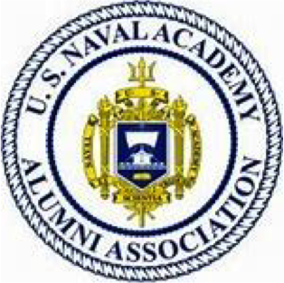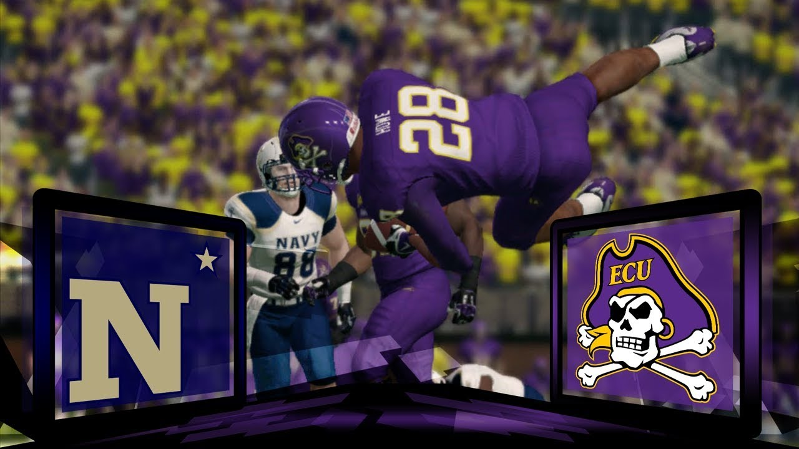

**RSVP Please for a F&H Headcount**

**Contact Bob Culler at 913 488-6319 text or email** [**bob.culler@1974.usna.com**](mailto:bob.culler@1974.usna.com)

**I Can’t Attend But…**

Please send your $25 annual Greater KC Chapter Annual dues for 2022 to Treasurer Eric Carlson ’74: 12216 Carter OP 66213

Check: Greater KC Metro Chapter USNA AA

-0R- bring it with you to ECU or Air Force

**Mark Your Calendar**

**OCT 1 Navy at Air Force Joint Watch Party at O’Neill’s Restaurant in Leawood, KS, 11 AM (future email)**

**OCT 15 All Service Academy Golf Scramble at Trails West Golf Course, on post at Fort Leavenworth, on October 15, 12 PM Shotgun Start (future email)**

**Note: Ads need to be turned in by April 22nd. Thank you!**

**COST**

Watch Party is FREE. Order Your Own Food/Drink

**CONFLICTS**

NO GAME time conflicts with area teams like KU, KState, Mizzou playing at 5:00 PM

**WHEN**

Saturday, Sept 24

Suggest Arrive at 4:30

5:00 PM Kickoff

Order Dinner from Menu

**WHERE**

Fox & Hound

10428 Metcalf, Indian Creek Shopping Center

<http://www.foxandhound.com>

Greater KC Metro Chapter USNA Alumni Association Football Watch Party

2022 Navy at East Carolina (ECU)

Come support our Naval Academy Football team. Alumni, Friends, Family, Navy League,

Marine Corps, and USNA Parents are welcome to Join In

*Reserved Room at Fox & Hound in Overland Park*

*Game will be streaming on ESPN+ so you can’t watch it at home unless you subscribe*