Support the Navy League
and U.S. Blue Angels visit to Kansas City
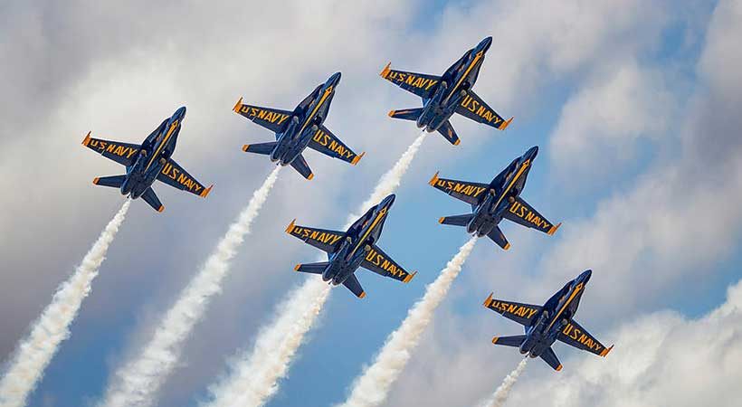
Join us for a very special engagement! On Friday, July 5th the Navy League of the United States, Greater Kansas City Council will host a special viewing party for the U.S. Navy Blue Angels at the Wheeler Downtown Airport. Come join us for an afternoon of VIP treatment while supporting the effort of hosting the U.S. Blue Angels in Kansas City.
For a donation of $300, you and up to four guests may join us at this special V.I.P. viewing of the U.S. Navy Blue Angels while they do their final practice run for the Kansas City Air Show. After the show, the Blue Angels will great our special guests. Lunch will be catered, and V.I.P. seating and parking will be included as well. Contact Ward Cook (816) 210-3276 or George Bukaty 816-753-3633 for questions or more information.
Please Include your name, Address, Phone, email, and the names of your guests. You may remit a check to the Navy League of the United States Greater Kansas City Council: P.O. Box 411361 Kansas City, MO 64141 or visit our website for more information and to pay by credit card. www.navyleaguekansascity.org
Name: ______________________________________________
Address: ____________________________________________
Phone: _______________ E-MAIL________________________
Guest Names: ______________________________________________

