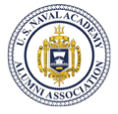

Navy- Air Force Football Watch Party

What: Navy versus Air Force Televised Football Game, CBSSN

When: Saturday, October 7, 2017; Kickoff Time is 2:30 PM Central

Where: Coaches Bar and Grill, http://www.coach-s.com
9089 W. 135th Street, Overland Park, KS 66223
(913) 897-7070 (near the Scheels Soccer Complex)

Lunch: Lunch is on your own off Coach’s menu but recommend arrival at 1:00-1:30 PM to get your food/drink order in before kickoff. http://www.coach-s.com/food.html

Attire: Navy or Air Force Spirit Wear

Who: USNA Alumni, USAFA Alumni, USNA Parents, USAFA Parents, Family Members

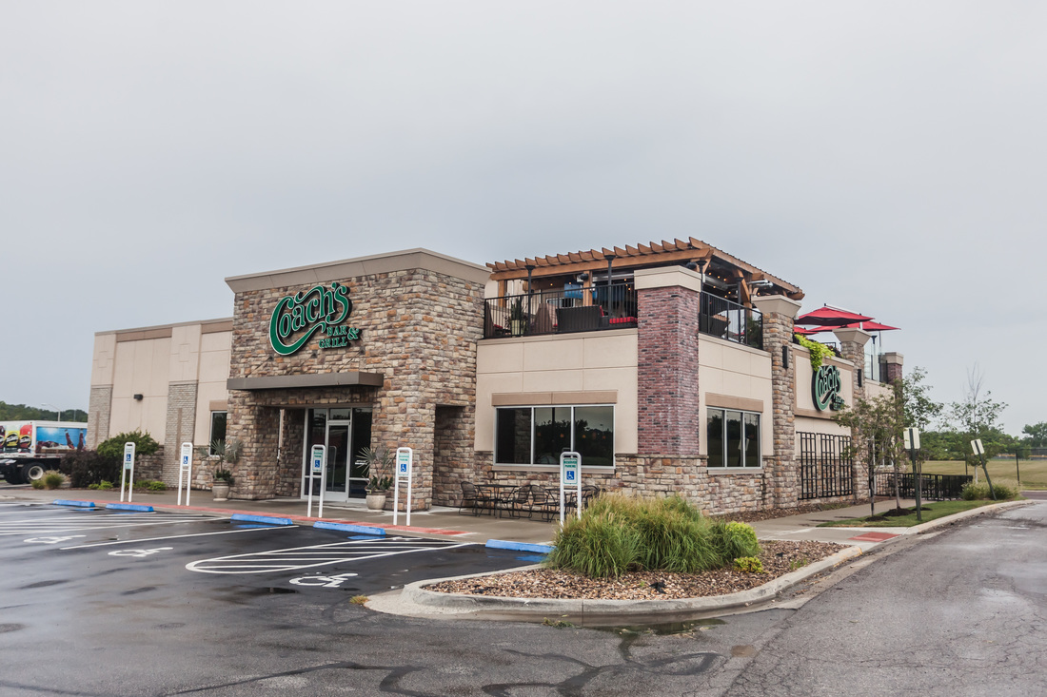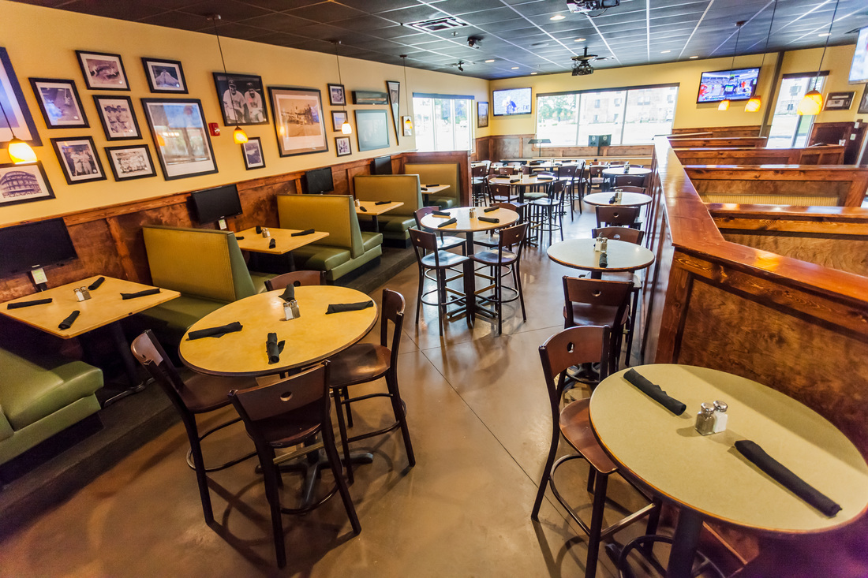
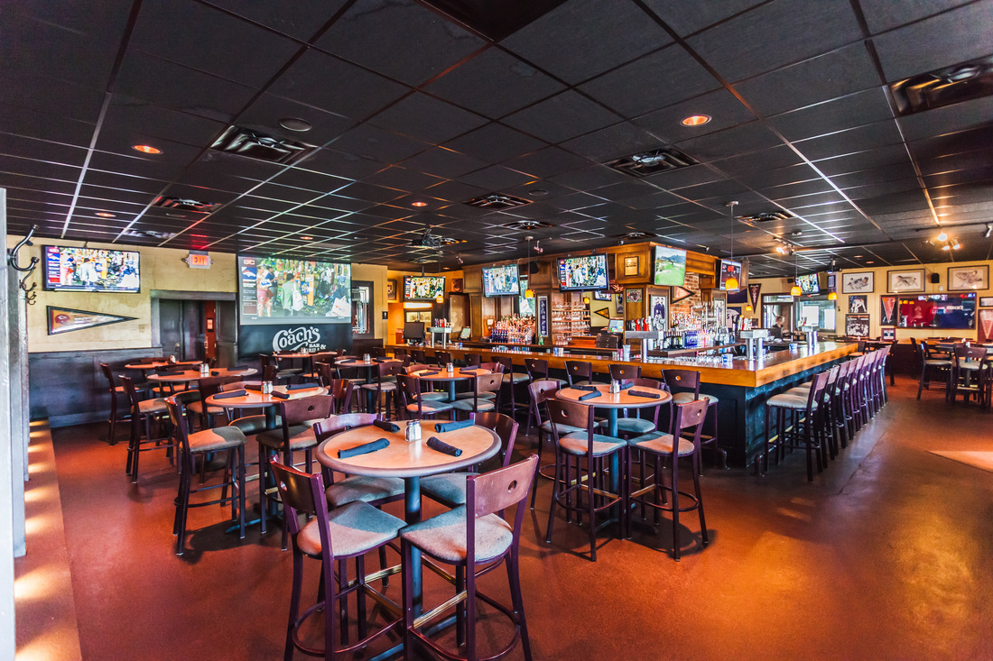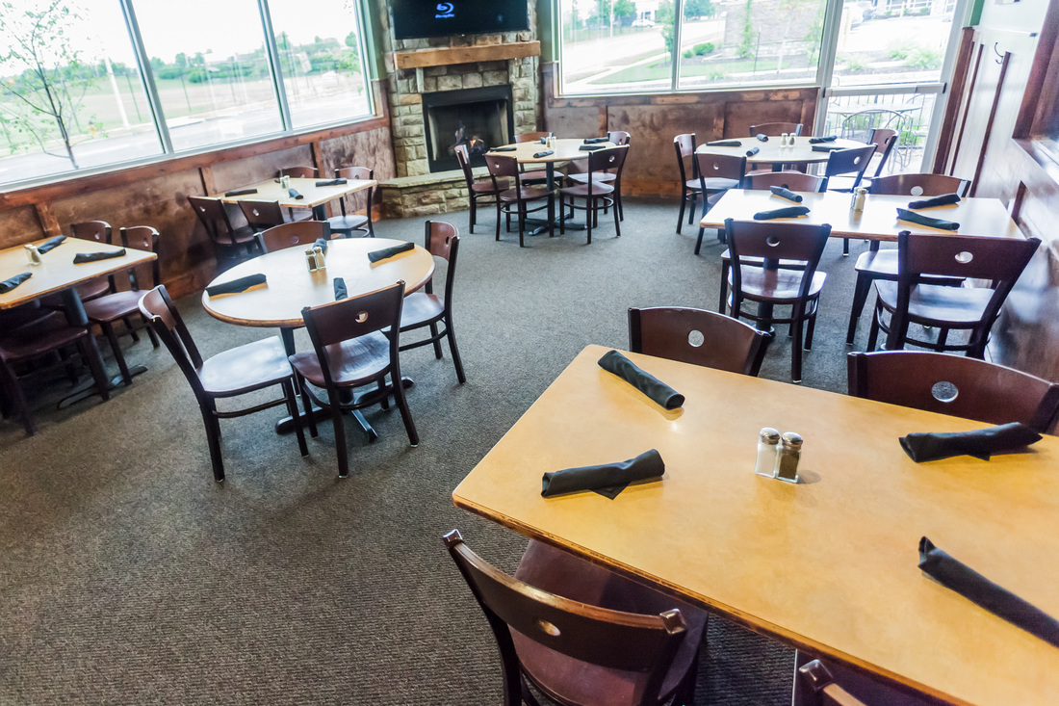

RSVP: The room reserved (upper right picture) will hold 42. RSVP by October 2 please.
Navy: Bob Culler email: bob.culler@1974.usna.com
Air Force: Greg Shuey: gshuey@tensortech.com

